PARENTAL/GUARDIAN CONSENT FORM

Child’s Name: Date:

Date of Birth:
Month Day Year

Health Card Number

Do you have OUT OF COUNTRY HEALTH INSURANCE? □Yes □ No
- Company optional - Phone No.
See our insurance policy optional - Policy No.

I, the undersigned, give permission for my son/daughter to
participate in the following :

An organized trip Emsland Sport en Recreatie, Emslandweg 17, 7731 RP, Ommen, Netherlands from Wednesday 31 July to Sunday August 4 2024, with the goal of exposing our child to a cross-cultural experience, serving virtue, training & sports in a predominately Christian environment.

I, the undersigned also give permission for appointed representatives of Shepherd’s Place to act as the Responsible Guardians for our son/daughter for the duration of the activity.

Signed: Date: (Parent/Guardian)

Parent Name: (please print) :

Parent Address: (please print)

Home Telephone: ( )

Business Telephone: Father ( ) Mother ( )

Emergency Contact: Name Telephone

Allergies:

Special Needs & or medication

CONSENT FOR USING IMAGES OF CHILDREN

To comply with the UK data Protection Act 1998, I, the undersigned, give permission / do not give permission (delete as appropriate) to the organizers of this trip for images of my son/daughter to be used in printed promotional publications or on the websites of the organizations involved.

(Parent/Guardian)

Signed:

Date:

PAYMENTS

Costs for participants are 125 euros including food, accommodation and transportation from Shepherd's Place Church - The Hague to the camp site and back.

Payment should be made to :
Europe Rabobank 126087636
Account Name: St Shepherd’s Place Voorburg.
Bank code: RABONL2U,
Swift code: NL81RABO0126087636
Pledge to pay sign on or before July 10th 2024 (installment payments plan is possible preferably 3-4 installments)
(Parent/Guardian)

Signed:

Date:

Payment link: https://bit.ly/ytpc24pay
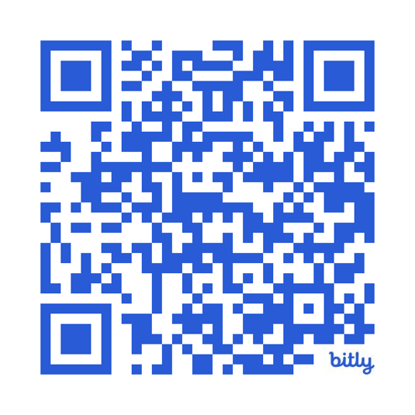
Payment QR Code:

